# Overview

When creating this Color Palette I had specific roles I wanted to be filled.

* One primary background color, which would be some kind of shade of off-white.
* One primary background color for containers that sit atop the background. This would be some kind of shade of tan, which represents the color of cooked dough as well as paper as if reading from a classic menu.
* One attention grabbing color, which would be a shade of red. The color red is energetic, representing the quickness of Chuck’s Pizza
* Two accent colors that would assist with grabbing attention, but have a lower hierarchy than the above. I wanted a green color, which would represent the greenery items that are common on pizza and be a good complementary color to the red, that have the lowest of the three hierarchy. And a shade of yellow/orange that would represent the cheese on pizza, and like red, is energetic and attention grabbing. But the intensity would be lower and would be used for secondary hierarchy items.

There were a few things I wanted to avoid when creating this color palette:

* Avoid colors of blue and purple
* Especially purple is not a good color to choose with food, as it suppresses appetites. And there are very few food that are blue that go on top of pizza.
* Because of those two I wish to avoid, that takes out the bottom half of the color wheel, knocking out triad, complementary, and their subtypes.

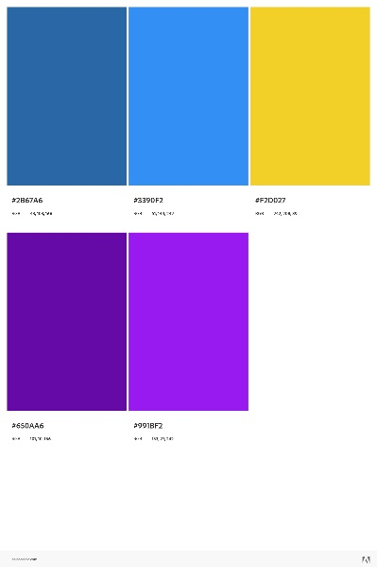 This is a split complementary palette. Since it contains many blues and purples, it has been rejected.

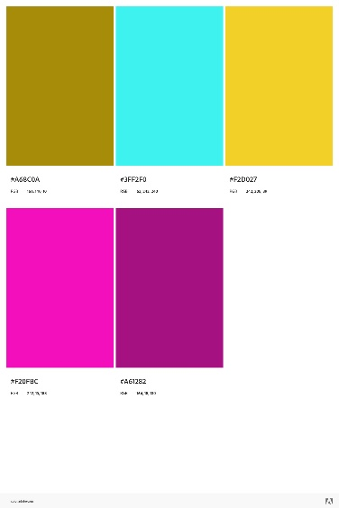 This is a triad palette. The pink and blue are too close to hierarchy. Rejected.

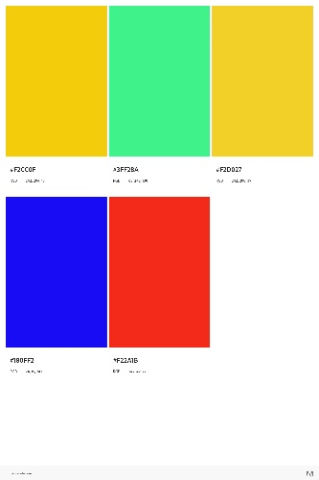 This is a square palette. The green is far to powerful and there is a blue. Rejected.

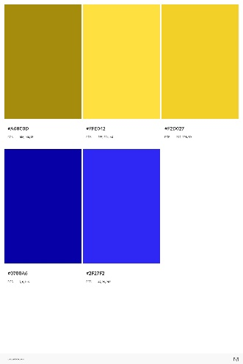 This is a complementary palette. The two blues are undesirable. Rejected.

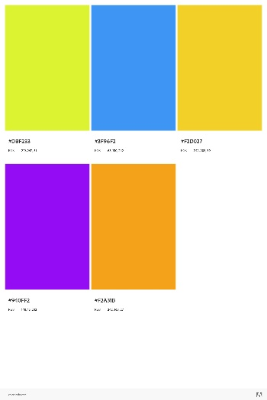 This is a double-split complementary palette. The yellow is alright, orange is a bit too strong, and the blue and purple ruin it. Rejected.

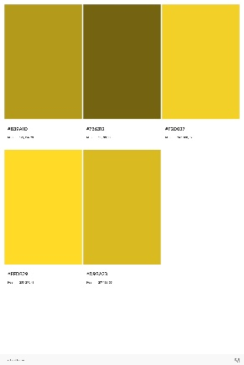 This is a shade palette. It lacks the color diversity I’m looking for, but the third yellow isn’t bad.

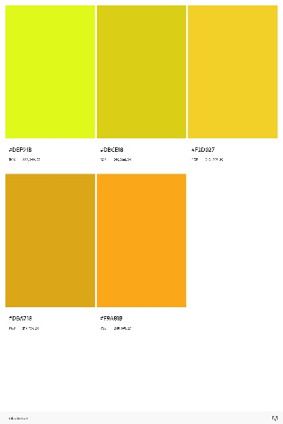 This is an Analogous palette. Like the previous, lacks diversity. Again, third yellow is similar to what I’m looking for.

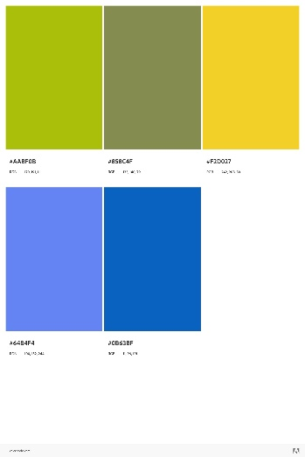 This is a compound palette. Has two blues and 2nd green is not appetizing.

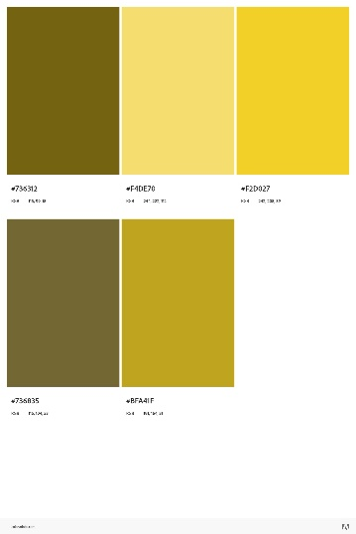 This is monochromatic. The second color isn’t terrible, but too bright for a background but not enough for a attention grabber.

This is the palette that will be used. It’s sort of an analogous-triad. This palette closely resembles the Italian flag, which has connotations of pizza and pasta.

